Project Title: Car Rental System

1) Project Description:
Car Rental System is a web-based application designed to facilitate car bookings for rent. The system includes two main user roles: Admin and Customer.
- Admin Section:
  - Admins can log in using secure credentials.
  - They can manage car details, including car name, color, plate number, rental price per day, and pickup location.
  - Admins have full CRUD (Create, Read, Update, Delete) functionalities for managing the car database.
  - They can view and approve customer booking requests.
- Customer Section:
  - Customers must first register and log in.
  - After logging in, customers can search for available cars based on pickup location and rental dates (from date to date).
  - Available cars are displayed, and customers can proceed to book a car.
  - Upon booking, a unique booking ID is generated.
  - Customers can check the booking status using their booking ID.
  - The rental payment is calculated automatically based on the number of rental days.

2) Key Features and Requirements:
- Add, update, and delete car details (Admin)
- Register and log in (Customer)
- Search and book cars based on location and dates
- Generate unique booking ID
- View booking status using ID
- Automated payment calculation based on rental duration
- Admin approval for booking confirmation

3) Expected Outcomes:
- User-friendly and responsive UI/UX design
- Integration of RESTful APIs for booking, car availability, payment, and status tracking
- Efficient and secure authentication system
- Smooth interaction between Admin and Customer functionalities

Actors:
- Admin
- Customer
Use Cases:
- Admin:
  - Login
  - Add/Update/Delete Cars
  - View Booking Requests
  - Approve/Reject Bookings
- Customer:
  - Register/Login
  - Search Cars by Location & Date
  - Book a Car
  - View Booking Status
  - Make Payment

Database Schema (MongoDB Collections)

User and admin Collection
{
_id,
name,
email,
password,
role: "admin" | "customer"
}

Car Collection

{
_id,
carName,
color,
plateNumber,
pricePerDay,
location,
availability: true | false
}

Booking Collection
{
_id,
customerId,
carId,
pickupLocation,
fromDate,
toDate,
bookingStatus: "pending" | "approved" | "rejected",
bookingId,
totalAmount,
paymentStatus: "unpaid" | "paid",
}

Payment Collection
{
_id,
bookingId,
amount,
paymentMethod,
paymentDate,
status: "success" | "failed"
}

Functionalities we can add
- Role-based authentication (Admin vs. Customer)
- Filter cars by location and date
- Car booking with status update
- Generate unique Booking ID
- Calculate price based on number of days
- Admin dashboard for approvals
- Email notifications (optional)
- Booking history for users

Test Cases for Car Rental System
Test Case ID | Test Scenario | Test Steps | Expected Result | Role
TC001 | Admin Login | Enter valid admin credentials and submit | Admin dashboard is displayed | Admin
TC002 | Admin Login - Invalid | Enter incorrect credentials | Error message shown | Admin
TC003 | Add New Car | Admin fills car details and submits | Car is added to DB and listed | Admin
TC004 | Update Car Details | Admin edits car info | Car details updated in DB | Admin
TC005 | Delete Car | Admin deletes a car entry | Car removed from system | Admin
TC006 | View Booking Requests | Admin navigates to requests page | All pending requests are listed | Admin
TC007 | Approve Booking | Admin approves a booking | Status updates to "approved" | Admin
TC008 | Reject Booking | Admin rejects a booking | Status updates to "rejected" | Admin
TC009 | Customer Registration | Enter new user details and submit | Account created, redirected to login | Customer
TC010 | Customer Login | Login with valid credentials | Dashboard with search option shown | Customer
TC011 | Search Car (Valid) | Enter valid location and date range | List of available cars shown | Customer
TC012 | Search Car (Invalid) | Enter non-existent location/date | "No cars available" message shown | Customer
TC013 | Book a Car | Select car, provide details, confirm | Booking ID generated, status pending | Customer
TC014 | View Booking Status (Valid ID) | Enter valid booking ID | Status (Pending/Approved/Rejected) shown | Customer
TC015 | View Booking Status (Invalid ID) | Enter invalid booking ID | "No booking found" error | Customer
TC016 | Payment Calculation | Select car and rental days | Total price auto-calculated correctly | Customer
TC017 | Payment Success | Make payment with valid method | Status updates to "paid" | Customer
TC018 | Payment Failure | Simulate failed payment | Status remains "unpaid", error shown | Customer
TC019 | Duplicate Registration | Try to register with same email | "Email already exists" error | Customer
TC020 | Role-based Access | Try accessing admin routes as customer | Access denied message | Both

Tech Stack (MERN)
Component | Tech
Frontend | React.js
Backend | Node.js + Express.js
Database | MongoDB
Sequence Diagram
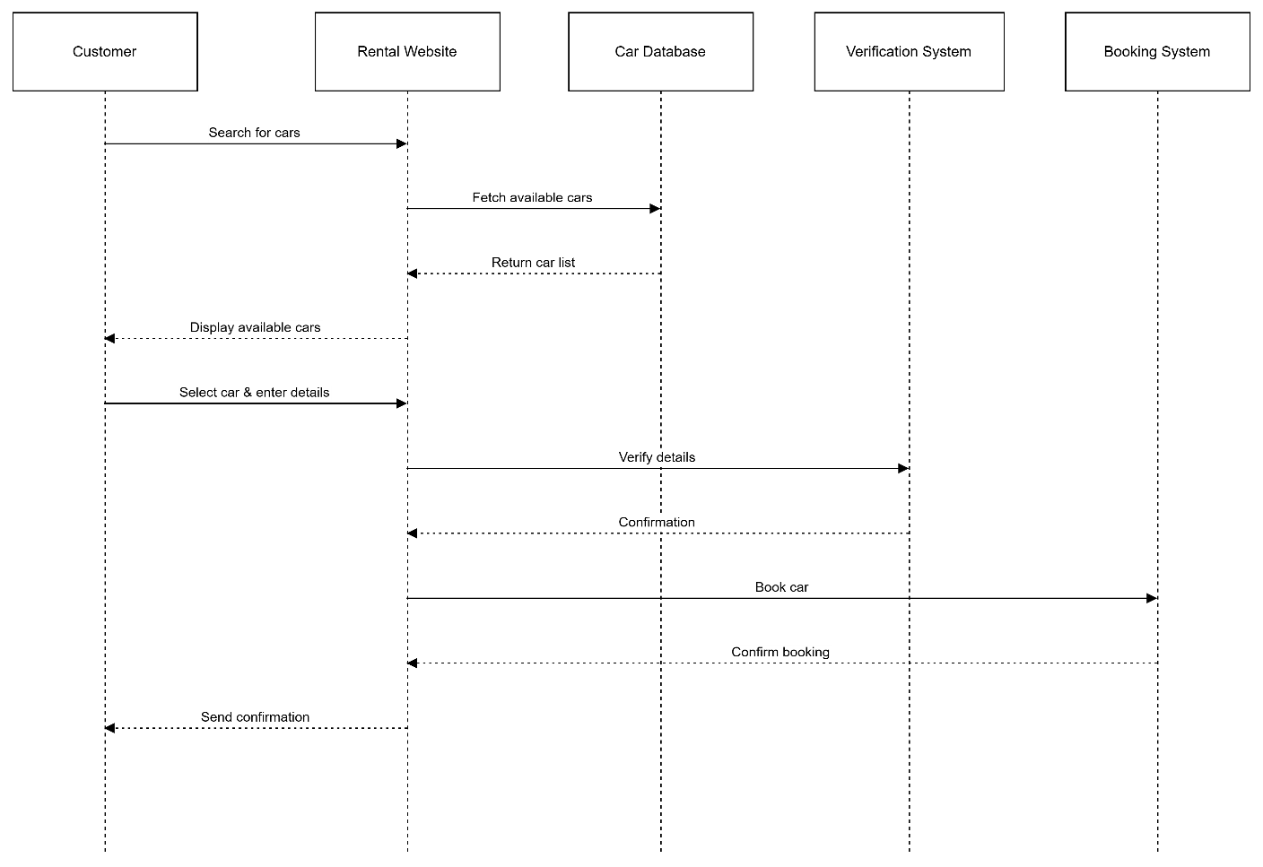
- Customer- searches for car -> Rental Website
- Rental Website- fetches available cars ->+ Car Database
- Car Database- returns available cars ->- Rental Website
- Rental Website- displays available cars -> Customer
- Customer- selects car and provides details -> Rental Website
- Rental Website- verifies details ->+ Verification System
- Verification System- confirms details ->- Rental Website
- Rental Website- books car ->+ Booking System
- Booking System- confirms booking ->- Rental Website
- Rental Website- sends confirmation -> Customer
- Customer should provide valid details:note -- Customer
- Rental Website should confirm booking:note -- Rental Website

Workflow diagram

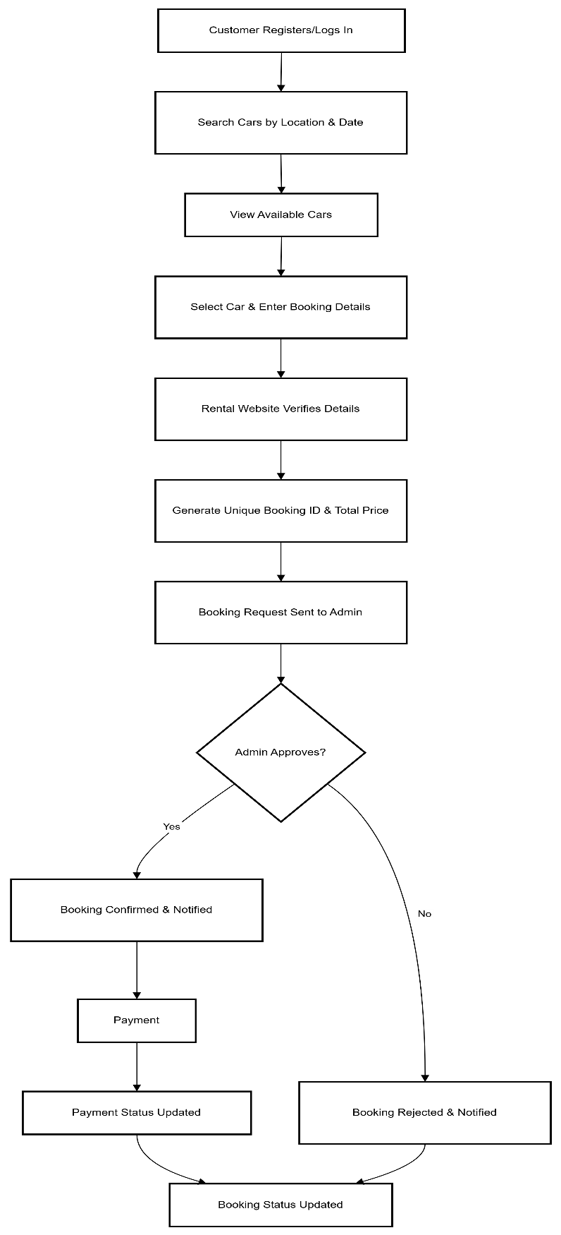

Functional Architecture Diagram

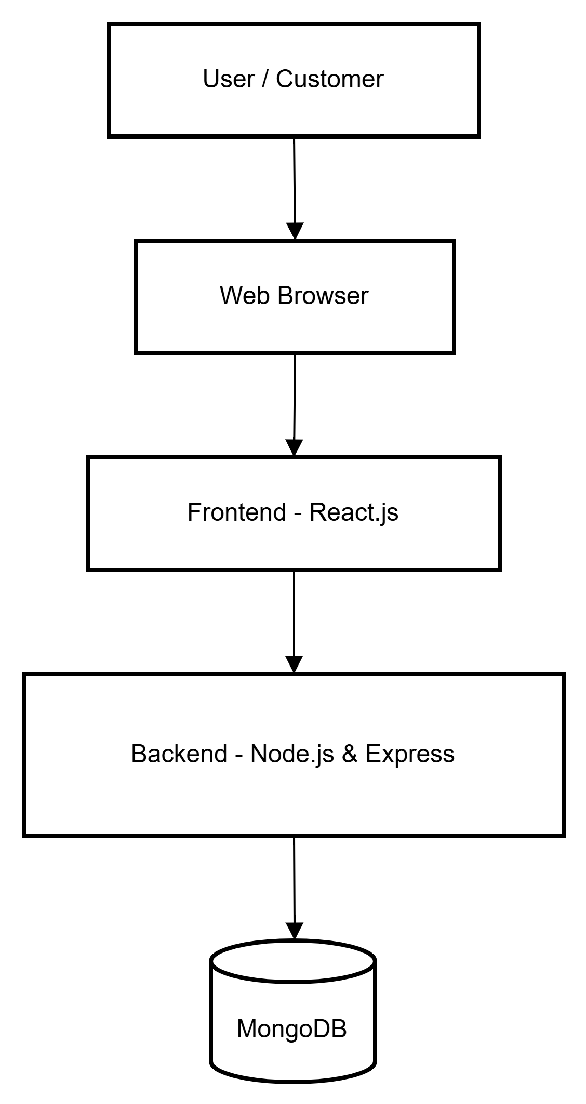

Database Diagram
